V3D Practicum week 6 A

Semester:
Course: VR3d
Version: 1.1
Author: Michael Schifferling
Patrick de Beer (Unity add-on)

Introduction:
In this practicum we will take a look at more advanced features of textures, such as mip-mapping, multi textures and environment maps.

Vizard Practical

Tutorials:
Execute the following Vizard Tutorials
- Multi-texturing
This tutorial shows how multiple textures can be applied to the same object
- Environmental mapping
In this tutorial you will see how to use environment mapping in Vizard

Assignment: Mip mapping
Download the mipmap project “Project practicum week 6 A” from sharepoint.
For more information about mip mapping in vizard, see:
- Vizard references (Appearance and Texturing -> Texture appearance and filtering)
When you run the program mipmapping.py (in folder Practicum week 6 a), you’ll see a brick wall moving forward and backward. Mip mapping is disabled.
Describe what you see with regards to the brick texture and the texture quality:
You can see the white parts between the bricks creating certain patterns at places where they are not supposed to be.
Adjust the Vizard project, so you can enable/disable mip mapping by pressing the ‘m’ key. Every press of the m key should initiate a different mip/mapping filter. Display the active mip mapping filter settings on screen with a UI label.
Cycle through all mip mapping filters. What do you see?
Min filter | Mag filter | Effect
viz.LINEAR | viz.LINEAR | Same as described above
viz.NEAREST | viz. LINEAR | Same as described above
viz.LINEAR_MIPMAP_LINEAR | viz. LINEAR | Image turns vague and greyish when far away
viz.LINEAR_MIPMAP_NEAREST | viz. LINEAR | Same as above, but you can see the texture switching between detail levels.
viz.NEAREST_MIPMAP_LINEAR | viz.LINEAR | Image turns vague when further away, but there is some pixel flickering
viz.NEAREST_MIPMAP_NEAREST | viz.LINEAR | Same as above, but you can also see the swithcing between the levels of detail
viz.LINEAR | viz.NEAREST | Patterns by created by the white spaces between the blocks on places where it shouldn’t be.
viz.NEAREST | viz. NEAREST | Same as above
viz.LINEAR_MIPMAP_LINEAR | viz. NEAREST | Image turns vague and greyish when far away
viz.LINEAR_MIPMAP_NEAREST | viz. NEAREST | Same as above, but you can see the texture switching between detail levels.
viz.NEAREST_MIPMAP_LINEAR | viz. NEAREST | Image turns vague when further away, but there is some pixel flickering
viz.NEAREST_MIPMAP_NEAREST | viz. NEAREST | Same as above, but you can also see the swithcing between the levels of detail

Assignment: Texture in shaders.
In the zip file you also find (in folder texture_6a) Vizard program texShader, a texture and 2 shader files.
- Open the Vizard project and create a shader object

shader = viz.addShader(vert=’ texturing.vert',frag= ‘texturing.frag' )

- In the Vizard project the texture is assigned to unit 0. To use a texture in a shader you have to add a uniform variable to the fragment shader to say which texture to use. Although the texUnit is an integer type in Vizard, you have to use the type sampler2D in the vertex shader.
Give the uniform a proper name, like colorMap
- The vertex shader needs to pass a texture coordinate to the fragment shader to properly display the texture. Therefore, you have to add a varying vec2 parameter to both the vertex shader and the fragment shader. Call this parameter ‘texcoord’.
The value of this parameter has to be assigned by the vertex shader. To do this use the following: gl_MultiTexCoord0.xy;
This call asks determines the currently active texture coordinates from the model.
- To use the color from the texture in the fragment shader, you need to use the glsl function :
texture2D(colorMap, texCoord). This function returns the pixel color of the texture at the specified coordinates.
- To see the final color, you have to assign it to gl_FragColor in the fragment shader.
- Return a gl_fragColor in the fragment program that is only 0.25 of the original texture intensity.
The final result should be something like this (Left star = the shader variant):
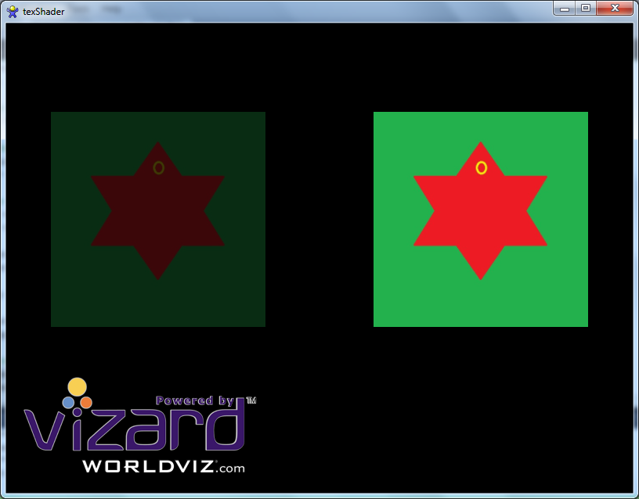

Assignment: Multi textures in shaders.
Also add the following to the above texturing assignment:
- Load another texture in Vizard. This should be different texture file, preferably hand painted with MSPaint for example.
- Pass a uniform float variable to the shader. This float number should be used by the shader to determine the mixing percentage of the two shaders. Keep this number in the range 0..1.
- Adjust the shadercode, so the mixing percentage determines which texture is the most visible.
At 0 the star texture should be 100% vizible and the new texture 0%.
At 1 the star texture should be 0% visible and the new texture 100%

Unity practicum week 6A

Assignment: Create a mirror in Unity
Follow this tutorial to create a plane that acts as a mirror in Unity: http://wiki.unity3d.com/index.php/MirrorReflection4

Assignment: Multi textures in shaders
Implement a shader in Unity which is similar to the “Texture in shader” Vizard assignment above (multi-texturing is not necessary).

Assignment: Normal map and cube map
Create a scene in which a normal map and/or a bump map is applied to an object, and show the effect clearly by adding a moving light.
Apply a static cube map to another object, and optionally also a dynamic cube map.

